Topalian
JavaScript
List
Generator
by
Christopher Andrew Topalian

All Rights Reserved
Copyright 2000-2024
Dedicated
to
God the Father

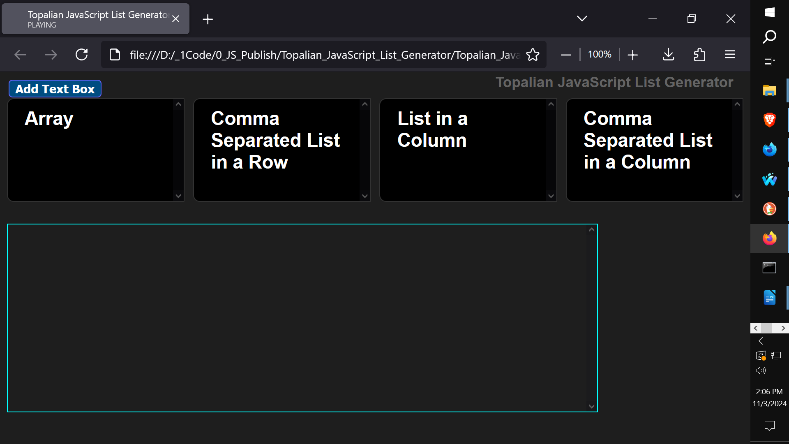

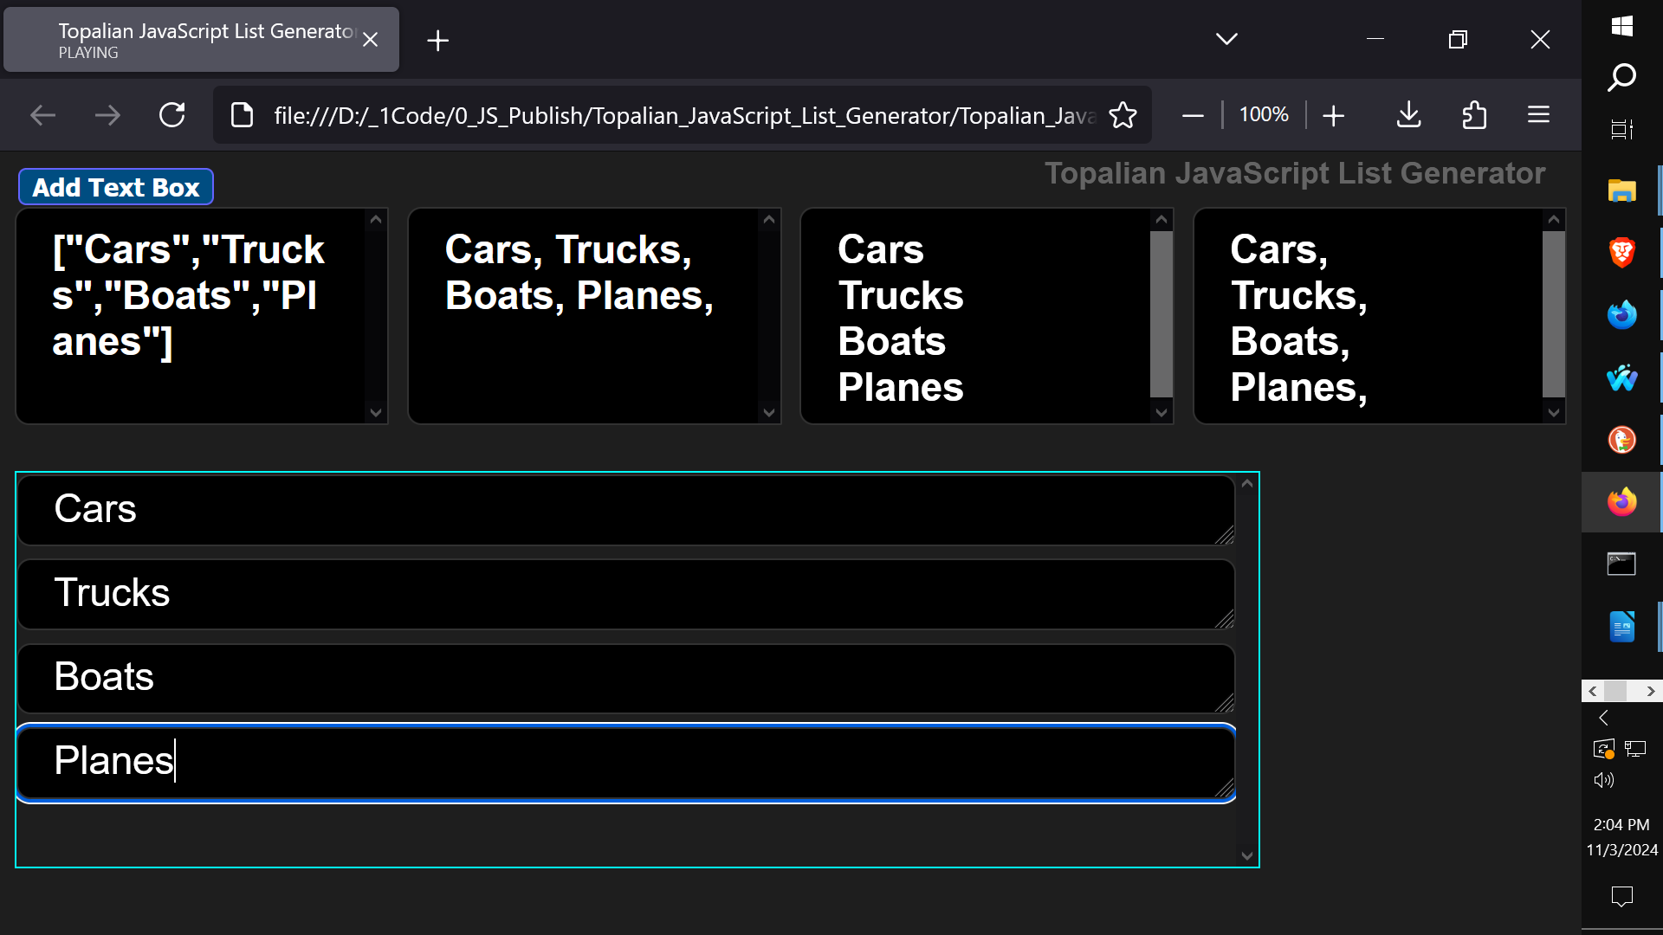
<!-- Dedicated to God the Father -->
<!-- All Rights Reserved Christopher Andrew Topalian Copyright 2000-2024 -->
<!-- https://github.com/ChristopherTopalian -->
<!-- https://github.com/ChristopherAndrewTopalian -->
<!-- https://github.com/ChristopherTopalian -->
<!-- Topalian_JavaScript_List_Generator_(Online_Version).html -->
<!-- Version 001 - (2024-11-03) -->

<html>
<head>
<title> Topalian JavaScript List Generator </title>

<style>

/* style001.css */

body
{
background-color: rgb(30, 30, 30);
font-weight: bold;
color: rgb(255, 255, 255);
}

button
{
background-color: rgb(0, 77, 129);
margin-left: 2px;
margin-right: 2px;
margin-top: 1px;
margin-bottom: 1px;
border-style: solid;
border-width: 1px;
border-color: rgb(100, 100, 255);
border-radius: 4px;
padding-left: 7px;
padding-right: 7px;
padding-top: 1px;
padding-bottom: 1px;
opacity: 1.0;
font-size: 14px;
font-weight: bold;
color: rgb(255, 255, 255);
text-align: center;
}

button:hover
{
background-color: rgb(7, 31, 47);
border-color: rgb(0, 255, 255);
color: rgb(0, 255, 255);
cursor: pointer;
}

button:active
{
color: rgb(255, 0, 255);
}

div:hover
{
border-color: rgb(0, 255, 255);
}

.textEntry
{
background-color: rgb(0, 0, 0);
border: solid 1px rgb(50, 50, 50);
border-radius: 8px;
padding-left: 20px;
padding-right: 20px;
padding-top: 5px;
padding-bottom: 5px;
font-family: arial;
font-size: 22px;
color: rgb(255, 255, 255);
}

.reportContainer
{
display: flex;
flex-direction: row;
gap: 10px;
}

.stringifiedArrayDiv
{
width: 300px;
height: 100px;
border: solid 1px rgb(50, 50, 50);
border-radius: 8px;
background-color: rgb(0, 0, 0);
padding-left: 20px;
padding-right: 20px;
padding-top: 10px;
padding-bottom: 10px;
color: rgb(255, 255, 255);
overflow-y: scroll;
word-wrap: break-word;
}

.listColumnDiv
{
width: 300px;
height: 100px;
border: solid 1px rgb(50, 50, 50);
border-radius: 8px;
background-color: rgb(0, 0, 0);
padding-left: 20px;
padding-right: 20px;
padding-top: 10px;
padding-bottom: 10px;
color: rgb(255, 255, 255);
overflow-y: scroll;
}

.csvListDiv
{
width: 300px;
height: 100px;
border: solid 1px rgb(50, 50, 50);
border-radius: 8px;
background-color: rgb(0, 0, 0);
padding-left: 20px;
padding-right: 20px;
padding-top: 10px;
padding-bottom: 10px;
color: rgb(255, 255, 255);
overflow-y: scroll;
word-wrap: break-word;
}

.listRowDiv
{
width: 300px;
height: 100px;
border: solid 1px rgb(50, 50, 50);
border-radius: 8px;
background-color: rgb(0, 0, 0);
padding-left: 20px;
padding-right: 20px;
padding-top: 10px;
padding-bottom: 10px;
color: rgb(255, 255, 255);
overflow-y: scroll;
word-wrap: break-word;
}

.entriesContainer
{
border: solid 1px rgb(50, 50, 50);
display: flex;
flex-direction: column;
overflow-y: scroll;
gap: 5px;
}

/*----*/

/* Dedicated to God the Father */
/* All Rights Reserved Christopher Andrew Topalian Copyright 2000-2024 */
/* https://github.com/ChristopherTopalian */
/* https://github.com/ChristopherAndrewTopalian */
/* https://sites.google.com/view/CollegeOfScripting */

</style>

<script>

// shortcuts.js

function ge(whichId)
{
let result = document.getElementById(whichId);
return result;
}

function ce(whichType)
{
let result = document.createElement(whichType);
return result;
}

function ba(whichElement)
{
let result = document.body.append(whichElement);
return result;
}

function ct(whichText)
{
let result = document.createTextNode(whichText);
return result;
}

function cl(whichMessage)
{
let result = console.log(whichMessage);
return result;
}

function gr(whichId)
{
let result = ge(whichId).getBoundingClientRect();
return result;
}

//----//

// Dedicated to God the Father
// All Rights Reserved Christopher Andrew Topalian Copyright 2000-2024
// https://github.com/ChristopherTopalian
// https://github.com/ChristopherAndrewTopalian
// https://sites.google.com/view/CollegeOfScripting

// worldVariables.js

let theTextEntryId = 0;

let textArray = [];

//----//

// Dedicated to God the Father
// All Rights Reserved Christopher Andrew Topalian Copyright 2000-2024
// https://github.com/ChristopherTopalian
// https://github.com/ChristopherAndrewTopalian
// https://sites.google.com/view/CollegeOfScripting

// makeEntriesContainer.js

function makeEntriesContainer()
{
let entriesContainer = ce('div');
entriesContainer.id = 'entriesContainer';
entriesContainer.className = 'entriesContainer';
entriesContainer.style.width = 80 + '%';
entriesContainer.style.height = 220 + 'px';
ba(entriesContainer);
}

//----//

// Dedicated to God the Father
// All Rights Reserved Christopher Andrew Topalian Copyright 2000-2024
// https://github.com/ChristopherTopalian
// https://github.com/ChristopherAndrewTopalian
// https://sites.google.com/view/CollegeOfScripting// makeInterface.js

function makeInterface()
{
let mainDiv = ce("div");
mainDiv.id = 'mainDivApp';
ba(mainDiv);

//-//

let buttonAdd = ce("button");
buttonAdd.textContent = "Add Text Box";
buttonAdd.onmouseover = function()
{
hoverSound();
};
buttonAdd.onclick = function()
{
clickSound();
makeTextEntryInput();
};
mainDiv.append(buttonAdd);

//-//

let reportContainer = ce("div");
reportContainer.id = "reportContainer";
reportContainer.className = 'reportContainer';
mainDiv.append(reportContainer);

//-//

let stringifiedArrayDiv = ce("div");
stringifiedArrayDiv.id = 'stringifiedArrayDiv';
stringifiedArrayDiv.title = 'stringifiedArrayDiv';
stringifiedArrayDiv.innerHTML = 'Array';
stringifiedArrayDiv.className = "stringifiedArrayDiv";
stringifiedArrayDiv.onmouseover = function()
{
hoverSound();
};
reportContainer.append(stringifiedArrayDiv);

//-//

let listRowDiv = ce("div");
listRowDiv.id = 'listRowDiv';
listRowDiv.title = 'listRowDiv';
listRowDiv.innerHTML = 'Comma Separated List in a Row';
listRowDiv.className = 'listRowDiv';
listRowDiv.onmouseover = function()
{
hoverSound();
};
reportContainer.append(listRowDiv);

//-//

let listColumnDiv = ce("div");
listColumnDiv.id = 'listColumnDiv';
listColumnDiv.title = 'listColumnDiv';
listColumnDiv.innerHTML = 'List in a Column';
listColumnDiv.className = 'listColumnDiv';
listColumnDiv.onmouseover = function()
{
hoverSound();
};
reportContainer.append(listColumnDiv);

//-//

let csvListDiv = ce("div");
csvListDiv.id = 'csvListDiv';
csvListDiv.title = 'csvListDiv';
csvListDiv.innerHTML = 'Comma Separated List in a Column';
csvListDiv.className = 'csvListDiv';
csvListDiv.onmouseover = function()
{
hoverSound();
};
reportContainer.append(csvListDiv);

//-//

mainDiv.append(ce('br'));
}

//----//

// Dedicated to God the Father
// All Rights Reserved Christopher Andrew Topalian Copyright 2000-2024
// https://github.com/ChristopherTopalian
// https://github.com/ChristopherAndrewTopalian
// https://sites.google.com/view/CollegeOfScripting

// makeTextEntryInput.js

function makeTextEntryInput()
{
theTextEntryId += 1;

let textEntry = ce("textarea");
textEntry.id = theTextEntryId;
textEntry.title = textEntry.id;
textEntry.className = "textEntry";
textEntry.style.height = 40 + 'px';
textEntry.onclick = function()
{
clickSound();
};
textEntry.onkeyup = function()
{
getAllTextareas();
};
ge('entriesContainer').append(textEntry);
}

//----//

// Dedicated to God the Father
// All Rights Reserved Christopher Andrew Topalian Copyright 2000-2024
// https://github.com/ChristopherTopalian
// https://github.com/ChristopherAndrewTopalian
// https://sites.google.com/view/CollegeOfScripting

// makeTitleOfApp.js

function makeTitleOfApp()
{
let mainDiv = ce('div');
mainDiv.style.position = 'absolute';
mainDiv.style.right = '20px';
mainDiv.style.top = '2px';
mainDiv.style.zIndex = 1;
ba(mainDiv);

//-//

let titleOfApp = ce('a');
titleOfApp.id = 'titleOfApp';
titleOfApp.textContent = 'Topalian JavaScript List Generator';
titleOfApp.href = 'https://github.com/christophertopalian/';
titleOfApp.target = '_blank';
titleOfApp.style.fontSize = '17px';
titleOfApp.style.fontWeight = 'bold';
titleOfApp.style.textDecoration = 'none';
titleOfApp.style.color = 'rgb(100, 100, 100)';
mainDiv.append(titleOfApp);
}

//----//

// Dedicated to God the Father
// All Rights Reserved Christopher Andrew Topalian Copyright 2000-2024
// https://github.com/ChristopherTopalian
// https://github.com/ChristopherAndrewTopalian
// https://sites.google.com/view/CollegeOfScripting

// getAllTextareas.js

function getAllTextareas()
{
textArray = [];

let theTextareas = document.getElementsByTagName("textarea");

for (let x = 0; x < theTextareas.length; x++)
{
textArray.push(theTextareas[x].value);
}

cl(textArray);

// show result as JSON stringified array
ge("stringifiedArrayDiv").innerHTML = JSON.stringify(textArray);

let theString = "";

for (let z = 0; z < theTextareas.length; z++)
{
theString += theTextareas[z].value;

theString += "<br>";
}

// send theString to listColumnDiv
ge("listColumnDiv").innerHTML = theString;

//----//

let theString2 = "";

for (let z = 0; z < textArray.length; z++)
{
theString2 += textArray[z] + ', ';
theString2 += "<br>";
}

// send theString2 to csvListDiv
ge('csvListDiv').innerHTML = theString2;

//-//

let theString3 = "";

for (let j = 0; j < textArray.length; j++)
{
theString3 += textArray[j] + ', ';
}

// send theString3 to listRowDiv
ge('listRowDiv').innerHTML = theString3;

//-//

return textArray;
}

//----//

// Dedicated to God the Father
// All Rights Reserved Christopher Andrew Topalian Copyright 2000-2024
// https://github.com/ChristopherTopalian
// https://github.com/ChristopherAndrewTopalian
// https://sites.google.com/view/CollegeOfScripting

// sound.js

let audioCtx = new (window.AudioContext || window.webkitAudioContext)();

function playTone(frequency, duration, waveType, volume, detune, attackTime, releaseTime, panValue)
{
let oscillator = audioCtx.createOscillator();
// 'sine', 'square', 'sawtooth', 'triangle'
oscillator.type = waveType;
oscillator.frequency.setValueAtTime(frequency, audioCtx.currentTime);
oscillator.detune.setValueAtTime(detune, audioCtx.currentTime);

let gainNode = audioCtx.createGain();
let pannerNode = audioCtx.createStereoPanner();

oscillator.connect(gainNode);
gainNode.connect(pannerNode);
pannerNode.connect(audioCtx.destination);

gainNode.gain.setValueAtTime(0, audioCtx.currentTime);

// attack
gainNode.gain.linearRampToValueAtTime(volume, audioCtx.currentTime + attackTime);
gainNode.gain.linearRampToValueAtTime(0,

// release
audioCtx.currentTime + duration / 1000 - releaseTime);

pannerNode.pan.setValueAtTime(panValue, audioCtx.currentTime);

oscillator.start();
oscillator.stop(audioCtx.currentTime + duration / 1000);
}

function hoverSound()
{
playTone(
300, // frequency
500, // duration
'sine', // waveType
0.2, // volume
50, // detune
0.2, // attackTime
0.2, // releaseTime
-0.5 // panValue -0.5 is left
);
}

function clickSound()
{
playTone(
400, // frequency
500, // duration
'sine', // waveType
0.2, // volume
50, // detune
0.2, // attackTime
0.2, // releaseTime
-0.5 // panValue -0.5 is left
);
}

//--//

// Dedicated to God the Father
// All Rights Reserved Christopher Andrew Topalian Copyright 2000-2024
// https://github.com/ChristopherTopalian
// https://github.com/ChristopherAndrewTopalian
// https://sites.google.com/view/CollegeOfScripting

// whenLoaded.js

function whenLoaded()
{
makeInterface();

makeEntriesContainer();

makeTitleOfApp();
}

//----//

// Dedicated to God the Father
// All Rights Reserved Christopher Andrew Topalian Copyright 2000-2024
// https://github.com/ChristopherTopalian
// https://github.com/ChristopherAndrewTopalian
// https://sites.google.com/view/CollegeOfScripting

</script>

</head>

<body onload = "whenLoaded();">

</body>

</html>

True Artificial Intelligence System
Tautology
1111
Contra-
-diction
0000
XOR
0110
XNOR
1001
AND
0001
NAND
1110
OR
0111
NOR
1000
MI
1101
MNI
0010
LP
0011
LC
1100
RP
0101
RC
1010
CI
1011
CNI
0100
16-Gon
For More Tutorials:

GitHub.com/ChristopherTopalian
GitHub.com/ChristopherAndrewTopalian
Sites.google.com/view/CollegeOfScripting
CollegeOfScripting.weebly.com
CollegeOfScripting.wordpress.com
Youtube.com/ScriptingCollege
Twitter.com/CollegeOfScript
Rumble.com/user/CollegeOfScripting

Dedicated to God the Father

This book is created by the
College of Scripting Music & Science.
Always remember, that each time you write a script with a pencil and paper, it becomes imprinted so deeply in memory that the material and methods are learned extremely well.

When you Type the scripts, the same is true. The more you type and write out the scripts by keyboard or pencil and paper, the more you will learn programming!

Write and Type every example that you find.
Keep all of your scripts organized.
Every script that you create increases your programming abilities.
SEEING CODE, is one thing,
but WRITING CODE is another.
Write it, Type it, Speak it, See it, Dream it.

CollegeOfScripting.weebly.com

